**Q1. Why is Java a platform independent language?**

**===================**

**Encapsulation: control the behaviour**

**=====================**

Ans**.** Java is platform independent because of its unique way of execution. When you write Java code, it's not directly converted into machine language like some other languages. Instead, Java code is compiled into bytecode. This bytecode is like a universal language that any computer with a Java Virtual Machine (JVM) can understand. So, when you run a Java program, you're actually running it on the JVM, not directly on your computer's hardware. Since the JVM is available for different operating systems (like Windows, macOS, Linux, etc.), Java programs can run on any system with a compatible JVM without needing to be recompiled. This makes Java platform independent.

**Q2. Why Java is not a pure object oriented Language?**

Ans. Java is not considered a pure object-oriented language because it incorporates features that go beyond the strict definition of object-oriented principles. It includes **primitive data types**, supports **static members and methods**, and allows **procedural programming**(If-Else, Loop )constructs alongside object-oriented concepts. However, Java is still largely object-oriented in its design, as it emphasizes objects, encapsulation, inheritance, and polymorphism as core principles of the language.

**Q3. What is Constructor ? Explain with the help of example.**

It has the same name as the class and is automatically called when an

object of that class is created. Constructors can take parameters for

initialization or be parameterless, providing default values. They ensure

that objects are properly initialized before use.

Example:

public class Car {

String make;

String model;

int year;

// Constructor with parameters

public Car(String make, String model, int year) {

this.make = make;

this.model = model;

this.year = year;

}

// Constructor without parameters (default constructor)

public Car() {

this.make = "Unknown";

this.model = "Unknown";

this.year = 0;

}

}

In this example, the Car class has two constructors: one with

parameters for custom initialization and one without parameters

for default initialization.

**Q4. What is Default Constructor ? Explain with the help of example.**

A default constructor is automatically provided by Java if

no explicit constructors are defined in a class. It initializes

instance variables to their default values (null for objects, 0

for numeric types, false for boolean). It's used when an object

is created without specifying constructor arguments.

example:

public class Person {

String name;

int age;

// Default constructor (provided by compiler)

public Person() {

this.name = null;

this.age = 0;

}

}

In this example, the Person class has a default constructor that

initializes name to null and age to 0.

**Q-5. Difference between Heap and Stack Memory in java. And how java utilizes this.**

**Heap Memory:**

* Heap memory is used for dynamic memory allocation.
* Objects in Java are created in the heap. When you create an object using the new keyword, memory is allocated from the heap to store that object.
* Heap memory is managed by the JVM's garbage collector. It automatically deallocates memory when objects are no longer in use (i.e., there are no references pointing to them), freeing up space for new objects.
* The heap memory is shared among all threads in a Java application.

**Stack Memory:**

* Stack memory is used for static memory allocation.
* Each thread in a Java application has its own stack memory.
* Stack memory stores method frames, which contain local variables, method parameters, and the return address.
* When a method is called, a new frame is pushed onto the stack, and when the method returns, the frame is popped off the stack.
* Stack memory is faster to access compared to heap memory because it operates in a last-in-first-out (LIFO) manner.

**How Java Utilizes Heap and Stack:**

In Java, primitive data types, references to objects, and local variables are stored on the stack. When you create an object, the reference to that object is stored on the stack, but the object itself is allocated memory on the heap.

Java manages memory automatically, so developers don't need to explicitly allocate or deallocate memory as they might in languages like C or C++. Memory allocation and deallocation are handled by the JVM's garbage collector, which periodically checks for objects that are no longer in use and frees up their memory.

In summary, heap memory is used for dynamically allocated objects, managed by the garbage collector, and shared among all threads, while stack memory is used for method frames and is private to each thread. Java's automatic memory management and division of memory between heap and stack contribute to its simplicity and safety.

**Q-6. How Java is different from C++?**

* Memory Management:
  + Java automatically handles memory management, while in C++, you have to manually allocate and deallocate memory.
* Platform Dependency:
  + Java programs can run on any system because they're converted into a universal format (bytecode), whereas C++ programs need to be recompiled for each platform.

Standard Libraries:

* Java has a broad standard library covering many tasks like I/O and GUI development. C++'s standard library is more focused on generic programming and lacks built-in support for some tasks like GUI development.

Syntax and Features:

* Java has simpler syntax and eliminates complex features like pointers, making code easier to read. C++ provides more control and has features like pointers and manual memory management.

**Q-7. What do you understand by an instance variable and a local variable?**

**Instance Variable:**

* An instance variable is like a characteristic or property of an object.
* It belongs to a specific object (instance) of a class.
* Each object has its own copy of instance variables, and they define the object's state.
* Instance variables are declared within a class but outside any method.

**Local Variable:**

* A local variable is like a temporary storage space used inside a method or a block of code.
* It exists only within the method or block where it's declared.
* Local variables are used for storing temporary data or performing calculations within a specific context.
* They are declared and used within methods, constructors, or blocks of code.
* It is necessary to initialize local variable otherwise it will generate an error.

**Q-8.Default Value of instance variable and a local variable?**

1)For Primitive Data Types:

a)int, long, byte, short: 0

b)float, double: 0.0

c)char: '\u0000' (null character)

d)boolean: false

2)For Reference Data Types:

a)Objects (instances of classes): null

b)Arrays: null

3)For Local Variables:Local variables must be initialized explicitly before use. If not initialized, the compiler generates an error.

4)For Instance Variables: Instance variables (non-static fields) are initialized to their default values when an object is created. If not explicitly initialized, they take on the default values mentioned above.

For example:

public class Example {

int intValue; // Default value: 0

double doubleValue; // Default value: 0.0

boolean boolValue; // Default value: false

String stringValue; // Default value: null

}

**Q-9.** **Encapsulation in java?**

**Encapsulation in Java** is a *process of wrapping code and data together into a single unit*, for example, a capsule which is mixed of several medicines.

class Circle {

private double radius;

private double area;

Circle(double radius){

this.radius=radius;

}

public void area(){

area = radius*radius;

System.out.println(area);

}

}

class Main{

public static void main(String args[]){

Circle obj = new Circle(4);

obj.area();

}

}

**Q-12. Constructor overloading?**

Constructor overloading is a concept in object-oriented programming where a class can have multiple constructors with different parameter lists. Each constructor performs a specific initialization task when an object of the class is created.

**Q-13. Define Copy constructor in java.**

In Java, a copy constructor is a special type of constructor used to create a new object by copying the state of an existing object. It is particularly useful when you want to create a new object with the same state as an existing one.

Here's an example of how you can implement a copy constructor in Java:

public class MyClass {

private int intValue;

private String stringValue;

// Constructor

public MyClass(int intValue, String stringValue) {

this.intValue = intValue;

this.stringValue = stringValue;

}

// Copy Constructor

public MyClass(MyClass other) {

this.intValue = other.intValue;

this.stringValue = other.stringValue;

}

// Getter methods

public int getIntValue() {

return intValue;

}

public String getStringValue() {

return stringValue;

}

public static void main(String[] args) {

MyClass original = new MyClass(10, "Hello");

MyClass copy = new MyClass(original); // Using copy constructor

System.out.println("Original: " + original.getIntValue() + ", " + original.getStringValue());

System.out.println("Copy: " + copy.getIntValue() + ", " + copy.getStringValue());

}

}

In this example, MyClass has a copy constructor which takes an object of the same class as an argument and initializes the new object with the state of the provided object.

When you create a new object using the copy constructor, it will have the same values for intValue and stringValue as the original object.

**Q-14. Can main method be overloaded?**

Yes, in Java, the main method can be overloaded just like any other method. Overloading means having multiple methods in the same class with the same name but different parameters. However, when you run a Java program, the JVM looks for a specific main method signature:

**public static void main(String[] args)**

**15 Comment on method overloading and overriding by citing relevant examples.**

Method overloading and method overriding are two important concepts in object-oriented programming, particularly in Java. They both involve the use of methods but serve different purposes.

1. Method Overloading:

Method overloading refers to defining multiple methods in a class with the same name but with different parameters. These methods can have a different number of parameters, different types of parameters, or both. The compiler determines which method to call based on the parameters provided during the method invocation.

Example of method overloading:

public class Calculator {

public int add(int a, int b) {

return a + b;

}

public double add(double a, double b) {

return a + b;

}

public int add(int a, int b, int c) {

return a + b + c;

}

}

In the Calculator class above, there are three add methods with different parameter lists. This is method overloading.

2. Method Overriding:

Method overriding occurs when a subclass provides a specific implementation of a method that is already provided by one of its parent classes (superclass or interface). The subclass overrides the behavior of the method in the superclass. This is often used in inheritance for achieving polymorphism.

Example of method overriding:

class Animal {

public void sound() {

System.out.println("Animal makes a sound");

}

}

class Dog extends Animal {

@Override

public void sound() {

System.out.println("Dog barks");

}

}

class Cat extends Animal {

@Override

public void sound() {

System.out.println("Cat meows");

}

}

public class Main {

public static void main(String[] args) {

Animal animal1 = new Dog();

Animal animal2 = new Cat();

animal1.sound(); // Output: Dog barks

animal2.sound(); // Output: Cat meows

}

}

In this example, both Dog and Cat classes override the sound method from the Animal class with their specific implementations. When you call sound method on animal1 and animal2, the overridden method in respective subclasses is executed, demonstrating method overriding.

In summary, method overloading is about having multiple methods with the same name but different parameters within the same class, while method overriding is about providing a new implementation of a method in a subclass that is already defined in the superclass.

**Q-17.Final , Finally and finalise?**

No, the final, finally, and finalize keywords in Java have different functions and serve different purposes:

**final:**

* final is a keyword in Java used to restrict the user. It can be applied to variables, methods, and classes.
* When applied to a variable, it means the variable's value cannot be changed once initialized.
* When applied to a method, it means the method cannot be overridden by subclasses.
* When applied to a class, it means the class cannot be subclassed.

**Finally**

* finally is a block in Java used with exception handling. It ensures that a section of code is always executed, whether an exception is thrown or not. It follows the try-catch block.
* It is often used for cleanup tasks like closing resources (files, sockets, database connections) regardless of whether an exception occurs or not.

**finalize:**

* + finalize is a method in Java used for garbage collection. It's called by the garbage collector on an object when it determines that there are no more references to the object.
  + It's generally not recommended to rely on finalize for resource cleanup because there's no guarantee when or if it will be called.

**Q.18 Is it possible that the ‘finally’ block will not be executed? If yes then list the case**.

* System.exit();
* Infinite Loop or Hang
* Thread Interruption:

**Q-20. Why is the main method is static in java?**

Making the main method static ensures that it can be called without creating an instance of the class .This means it can be invoked directly through the class name (ClassName.main()) without needing to instantiate the class . This is crucial because when you run a Java program, the JVM doesn't create an instance of the class but directly calls the main method.and allows it to serve as the entry point for the Java application.

**Q.21 Can the static methods be overridden?**

In Java, static methods cannot be overridden in the traditional sense. When you declare a static method in a class, it belongs to the class itself rather than to any specific instance of the class. Therefore, it is associated with the class's namespace rather than with any particular object.

When a subclass defines a static method with the same signature as a static method in its superclass, it does not override the superclass's static method; instead, it hides it. This means that the subclass's static method will be called only if it is directly invoked on the subclass itself, not on any instances of the subclass or its superclass.

**Q-23.Main objective of Garbage Collector?**

In short, the main objective of the garbage collector in Java is to automatically manage memory by reclaiming memory occupied by objects that are no longer in use, preventing memory leaks, and simplifying memory management for developers.

**Q-24.What part of memory - Stack or Heap - is cleaned in garbage collection process?**

Garbage collection in Java primarily focuses on cleaning up memory allocated on the heap, where objects are dynamically stored. When objects are no longer reachable or referenced by the program, they become eligible for garbage collection, and the memory they occupy is reclaimed. The stack, used for method invocation and local variables, is managed differently and doesn't undergo garbage collection; its memory is released automatically when a method returns or an execution context is popped off the stack.

**Q 30)Explain 5 real world scenerios where we will use Interface**

**or**

**Find 5 references in the libraries you used where Interfaces is used and why interface was used.**

Interfaces are used in plugin architectures, dependency injection frameworks, API design, callback mechanisms, and adapter patterns for providing contracts, enabling loose coupling, facilitating extensibility, handling asynchronous events, and promoting code reusability.

**Q 31)Why is the character array preferred over string for storing confidential information?**

Character arrays are preferred over strings for storing confidential information because they allow for explicit data clearing, mitigating security risks associated with immutable string objects.

**Q 32)What do we get in the JDK file?**

The Java Development Kit (JDK) provides tools and libraries necessary for developing Java applications. Inside the JDK file, you typically find:

* Java Compiler (javac): Used to compile Java source code files (.java) into bytecode (.class) files.
* Java Runtime Environment (JRE): Includes the Java Virtual Machine (JVM) and core libraries needed to run Java applications.
* Development Tools: Various tools like Javadoc (for generating
* documentation), JAR (for creating Java Archive files), and others for debugging, profiling, and monitoring Java applications.
* Libraries: Standard libraries and APIs necessary for Java development, including core classes, collections, networking, I/O, XML processing, and more.
* Documentation: API documentation, tutorials, and guides to help developers understand and use Java features effectively.

**Q 35) HashMap and HashTable in Java?**

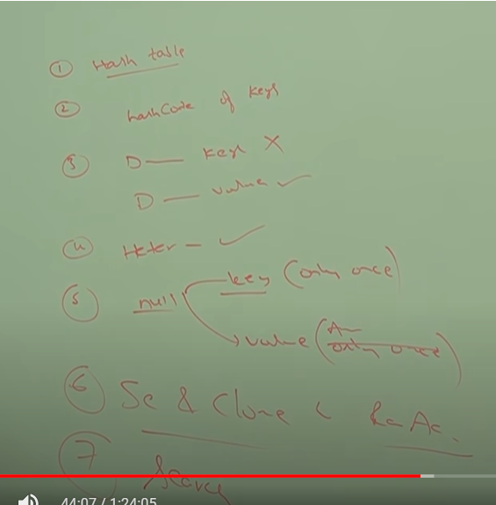

Constructor

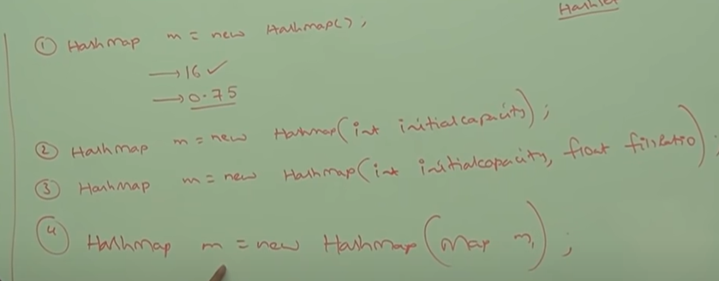

Example:

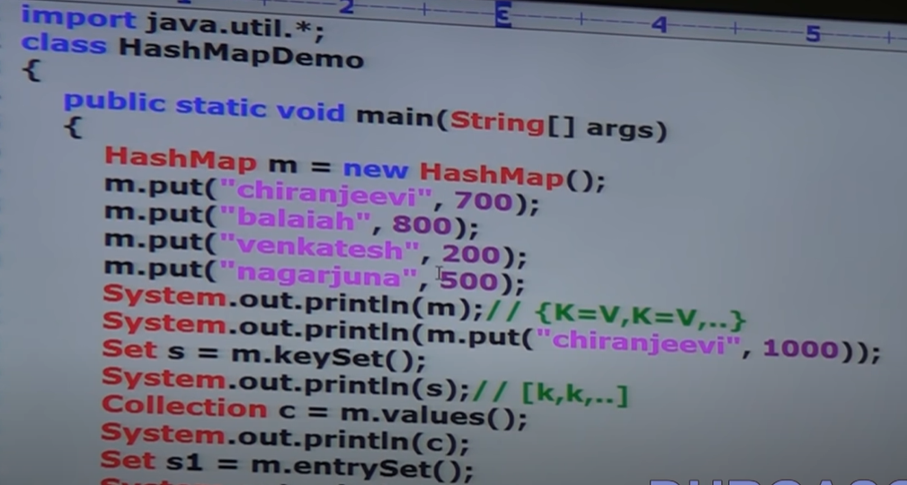

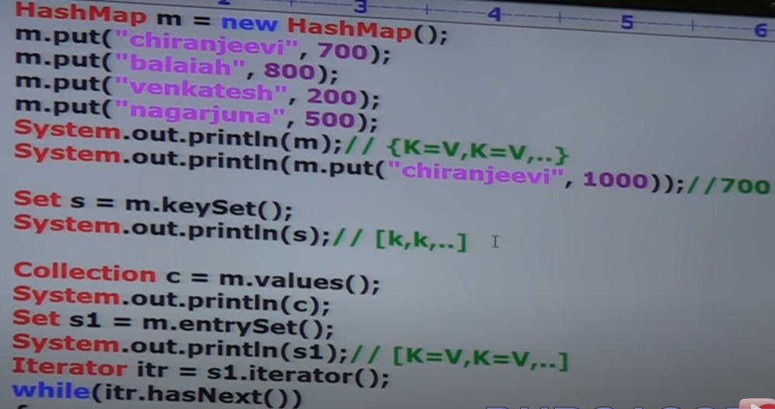

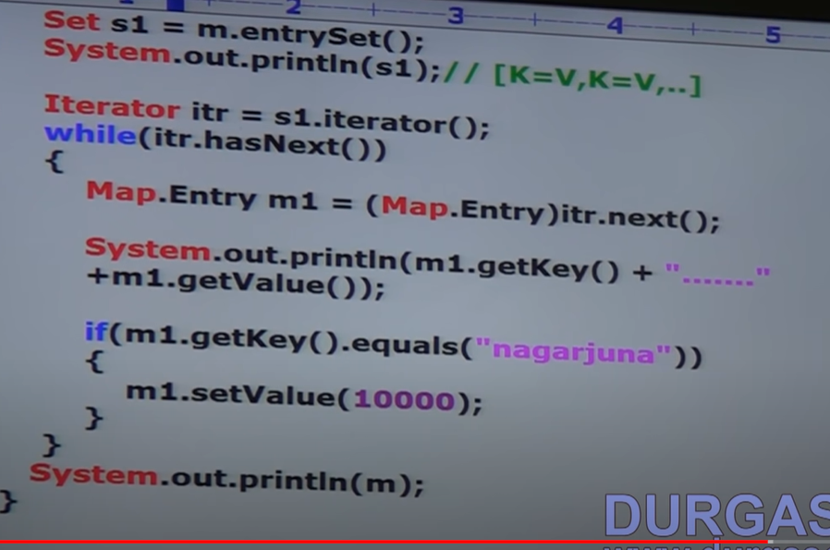

}

Difference between hashtable and hashmap

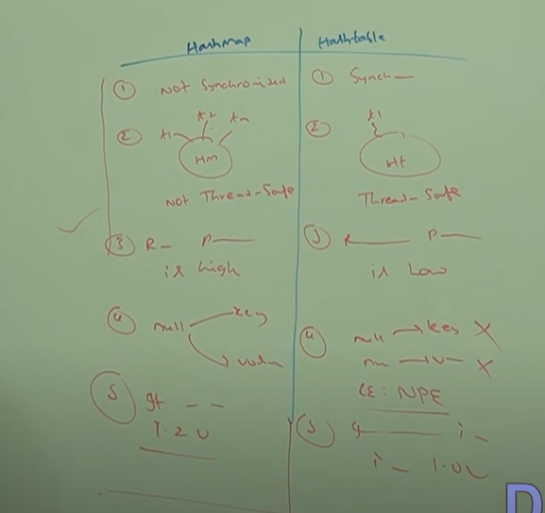synchronized

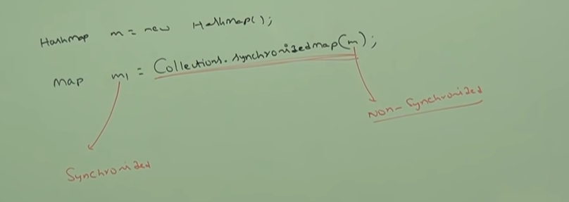

Make hashmap

Output:

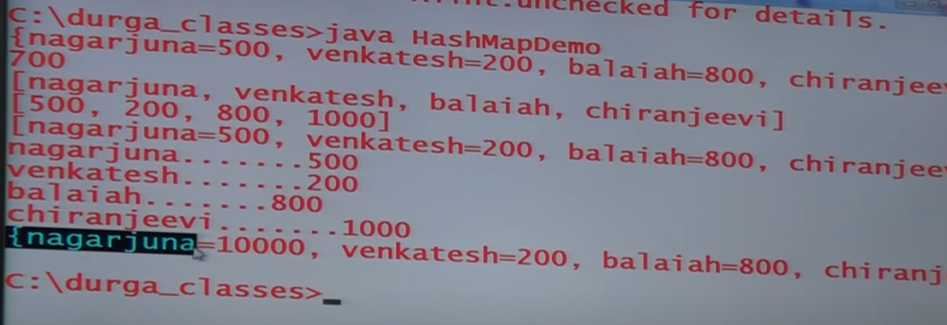

HashTable

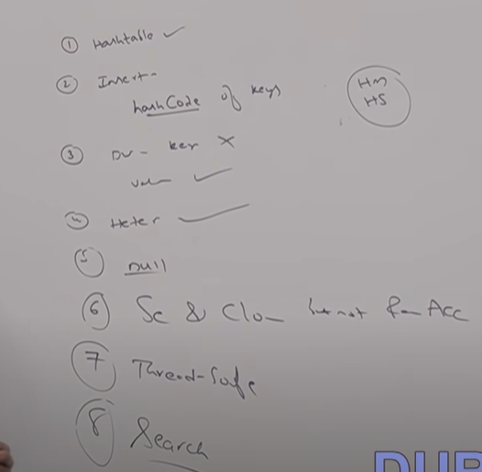

**Q 36) What makes a HashSet different from a TreeSet?**

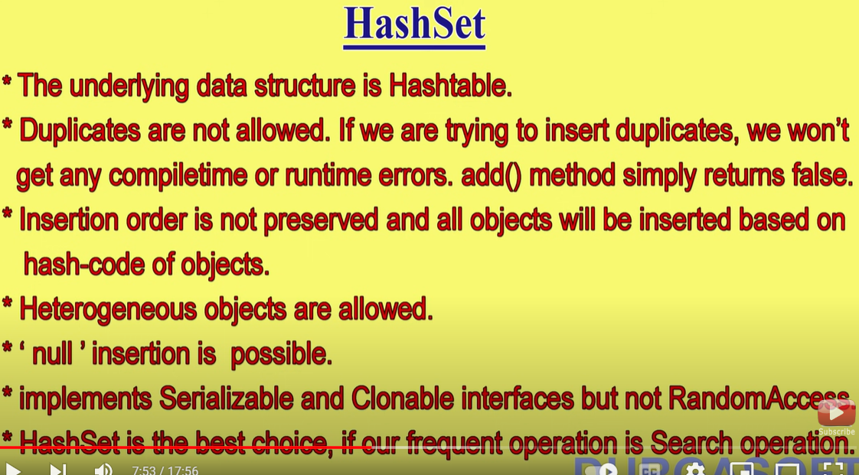

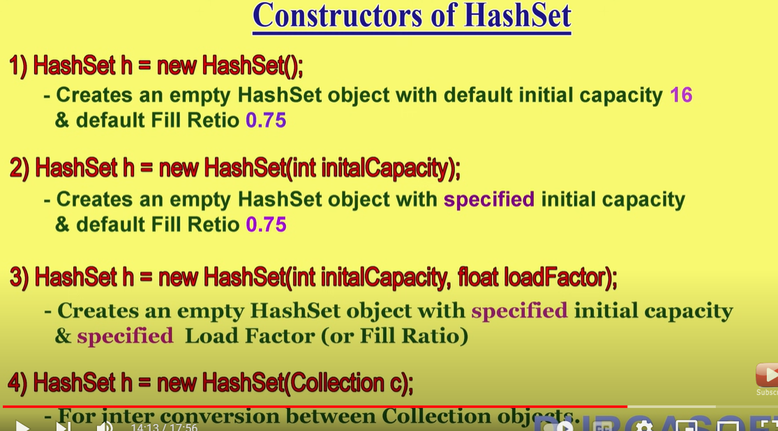

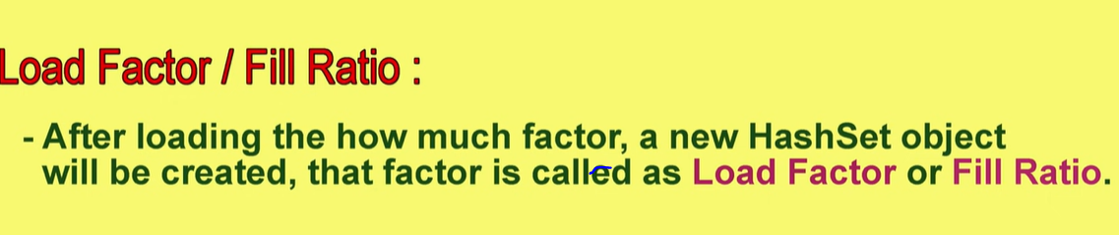

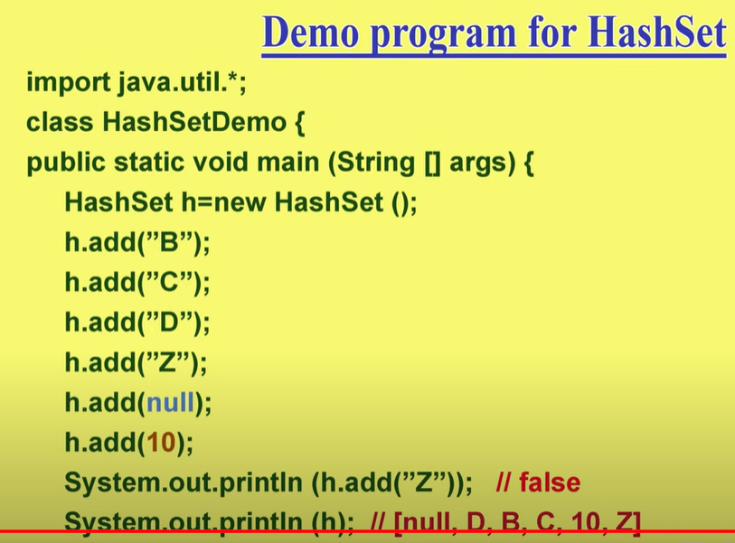

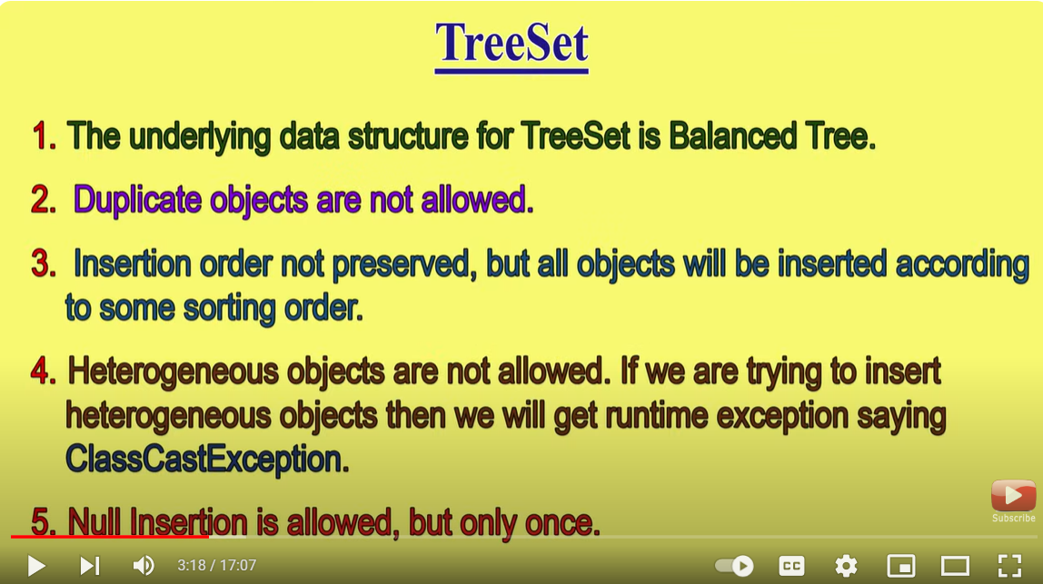

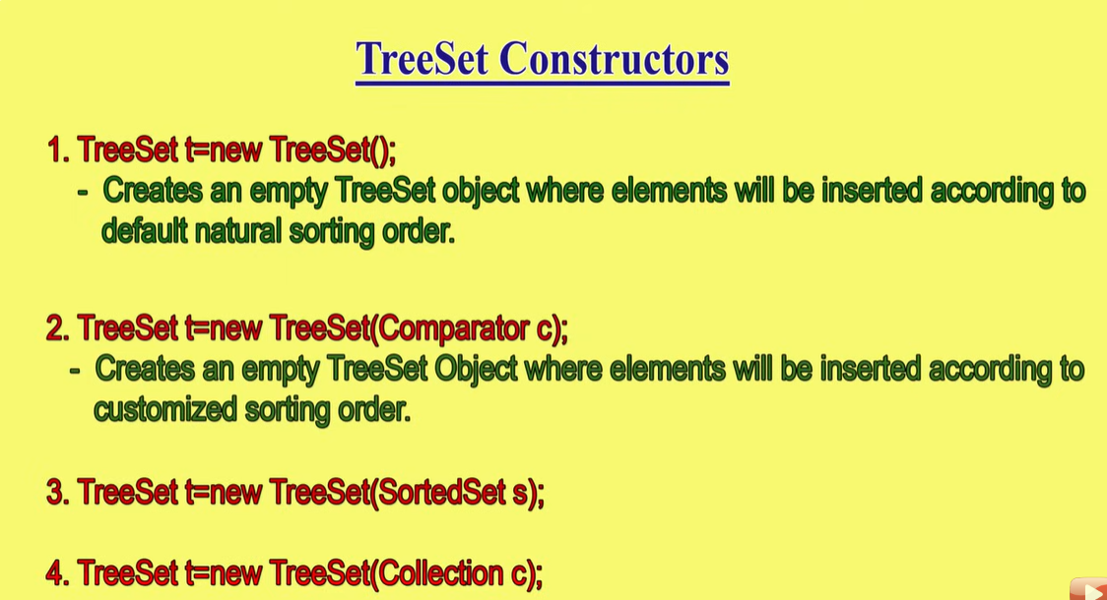

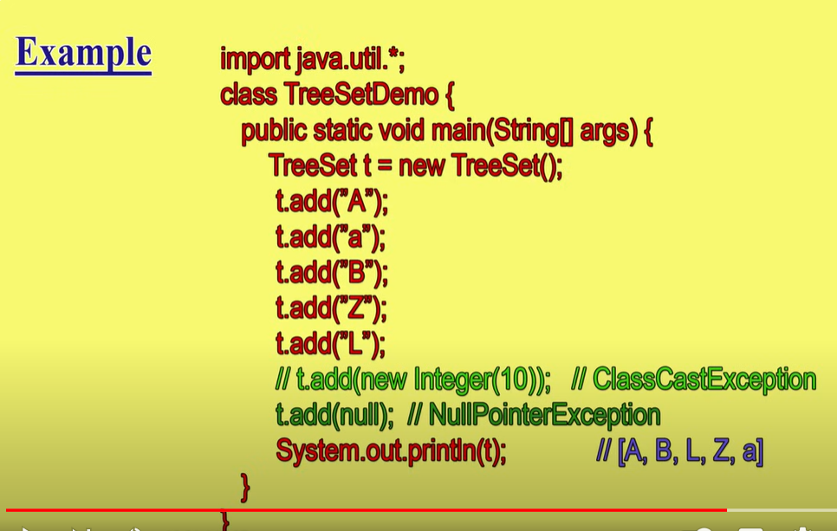

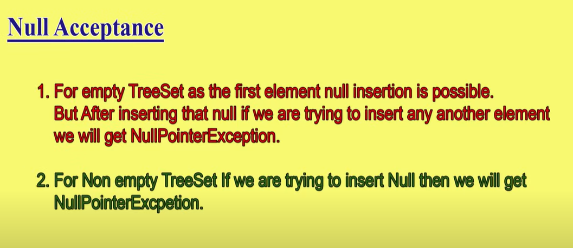

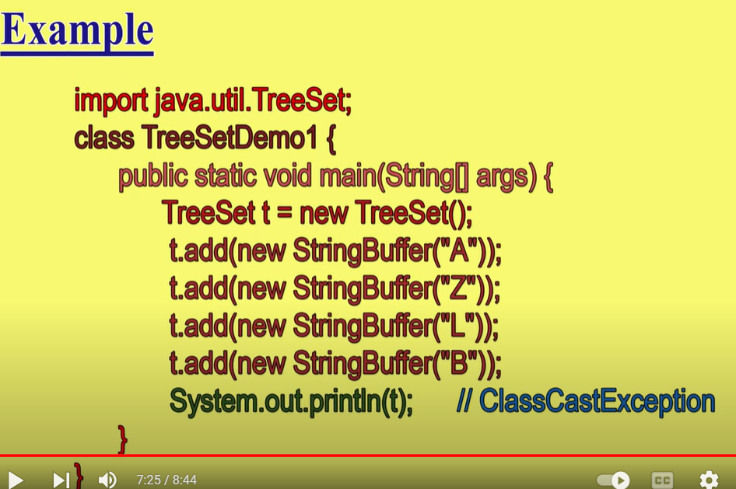

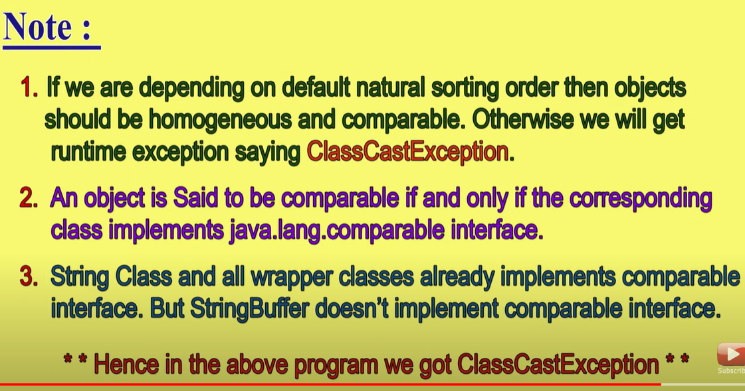

**Q 37)What are the differences between Exceptions and an Error ? Is there any similitude between the two ? [Explain with Example]**

Exceptions and errors are both mechanisms in programming languages to handle unexpected or exceptional situations, but they have some differences in their nature and usage.

Exceptions:

* Exceptions are typically used to handle exceptional conditions that occur during the execution of a program, such as division by zero, file not found, or network failure.
* Exceptions are recoverable, meaning the program can catch the exception and take appropriate action to handle the situation without terminating abnormally.
* Exceptions are typically thrown explicitly by the programmer using "throw" statements and caught using "try-catch" blocks.
* In many programming languages, exceptions are objects that encapsulate information about the exceptional condition, such as an error message or stack trace.

Example of using exceptions in Java:

try {

// Some code that might throw an exception

int result = 10 / 0; // This will throw an ArithmeticException

} catch (ArithmeticException e) {

// Handle the exception

System.out.println("An arithmetic exception occurred: " + e.getMessage());

}

Errors:

* Errors, on the other hand, typically indicate unrecoverable problems that are not expected to occur during normal program execution. These are severe issues that usually lead to termination of the program.
* Errors are often caused by system-level issues, such as running out of memory (OutOfMemoryError) or stack overflow (StackOverflowError).
* Unlike exceptions, errors are not meant to be caught and handled by the program because they usually indicate serious problems that cannot be resolved at the application level.

Example of an error in Java:

public class StackOverflowExample {

public static void main(String[] args) {

recursiveMethod();

}

public static void recursiveMethod() {

recursiveMethod(); // This will lead to a StackOverflowError

}

}

In summary, exceptions are used to handle recoverable exceptional conditions within a program, while errors indicate severe, typically unrecoverable problems that usually lead to termination of the program. While both are related to handling unexpected situations, they serve different purposes and are treated differently by the program.

| 38 | **What is Overloading ? What is Overriding ? Explain by example atleast 5.** |
| --- | --- |

Overloading:

Overloading refers to the ability to define multiple methods in the same class with the same name but with different parameters. This allows methods to perform different tasks based on the input parameters.

Here are five examples of method overloading:

* 1)Adding integers:
* public class Calculator {
* public int add(int a, int b) {
* return a + b;
* }
* public double add(double a, double b) {
* return a + b;
* }
* }
* 2)Finding maximum of numbers:
* public class MathUtils {
* public int max(int a, int b) {
* return (a > b) ? a : b;
* }
* public double max(double a, double b) {
* return (a > b) ? a : b;
* }
* }
* 3)Concatenating strings:
* public class StringUtils {
* public String concatenate(String str1, String str2) {
* return str1 + str2;
* }
* public String concatenate(String str1, String str2, String str3) {
* return str1 + str2 + str3;
* }
* }
* 4)Displaying messages:
* public class Printer {
* public void print(String message) {
* System.out.println(message);
* }
* public void print(int number) {
* System.out.println(number);
* }
* }
* 5)Calculating area:
* public class ShapeCalculator {
* public double calculateArea(double radius) {
* return Math.PI * radius * radius;
* }
* public double calculateArea(double length, double width) {
* return length * width;
* }
* }
* **Overriding:**
* Overriding occurs when a subclass provides a specific implementation of a method that is already provided by its parent class. The method in the subclass must have the same signature (name, parameters, and return type) as the method in the parent class.
* Here's an example:
* class Animal {
* public void makeSound() {
* System.out.println("Some generic sound");
* }
* }
* class Dog extends Animal {
* @Override
* public void makeSound() {
* System.out.println("Woof");
* }
* }
* class Cat extends Animal {
* @Override
* public void makeSound() {
* System.out.println("Meow");
* }
* }

| 39 | "What are the SOLID principles and how do they apply to Java ? [Explain with Example]  Single-Responsibility;  Open-Closed  Liskov Substitution  Interface Segregation  Dependency Inversion" |
| --- | --- |

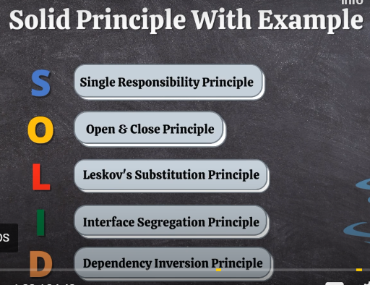

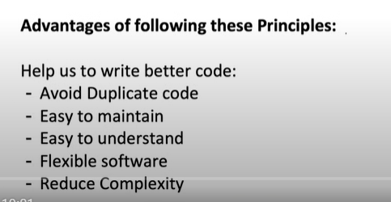

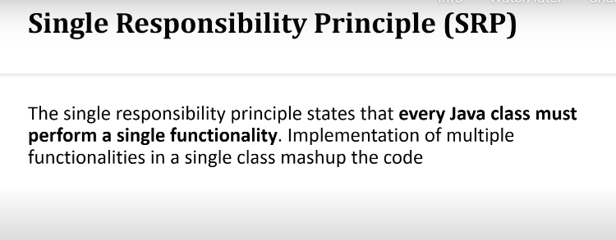

**Example:**

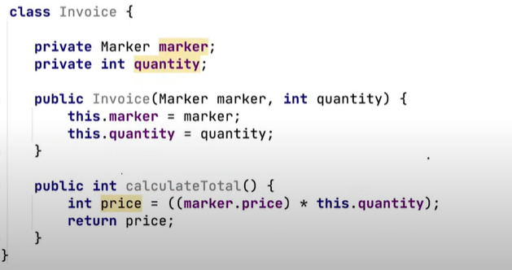

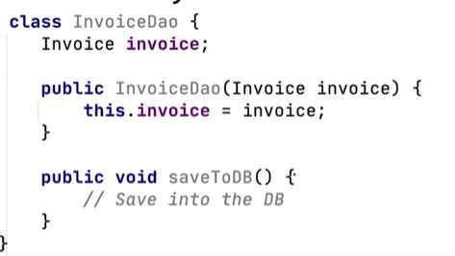

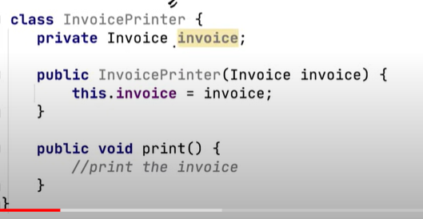

**Open/Closed Principle**

**Open for Extension but closed for modification**

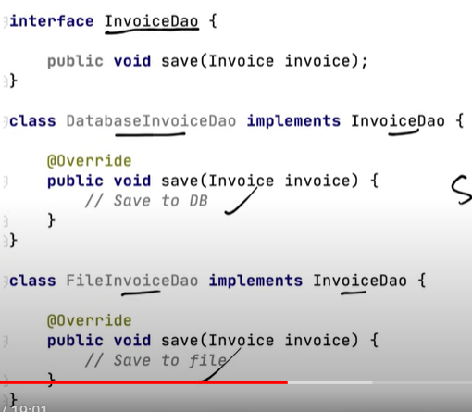

**Liskov Substitution Principle**

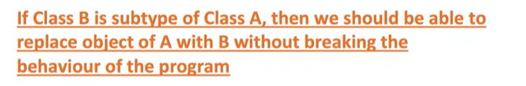

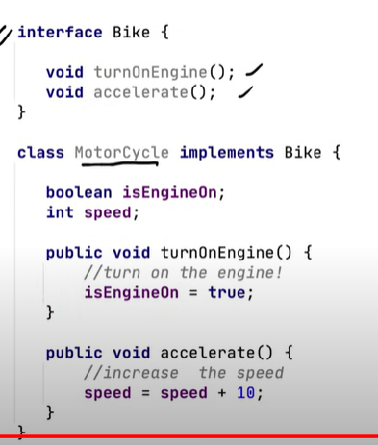

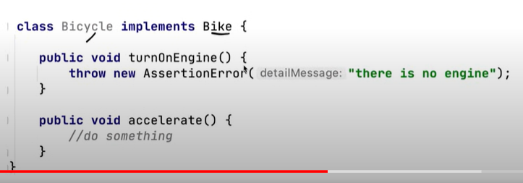

**Interface Segmented Principle**



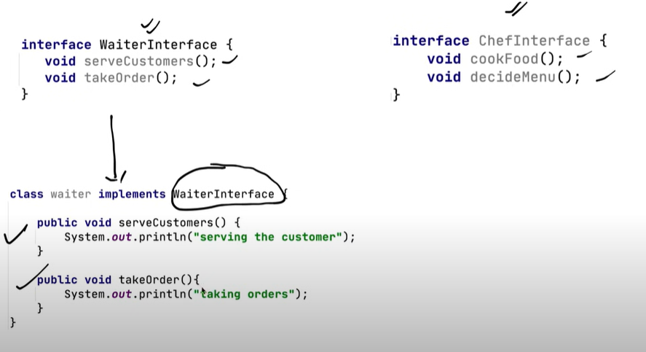

**Dependency Inversion Principle**



